Gifts of the Nile
The ancient Egyptians enjoyed many natural barriers. There were deserts to the east and west of the Nile River, and mountains to the south. This isolated the ancient Egyptians and allowed them to develop a truly distinctive culture.
The Nile is the world's longest river. It is over 4000 miles long! It is shaped like the lotus flower so often seen in ancient Egyptian art. Each spring, water would run off the mountains and the Nile would flood. As the flood waters receded, black rich fertile soil was left behind. The ancient Egyptian called this rich soil The Gift of the Nile.
Fertile soil for crops was not the Nile's only gift. The Nile gave the ancient Egyptians many gifts. Thanks to the Nile, these ancient people had fresh water for drinking and bathing. The Nile supported transportation and trade. It provided materials for building, for making cloth for clothes, and even for making paper - made from the wild papyrus weed, that grew along the shores of the Nile.
Because of the annual flooding of the Nile, the ancient Egyptians enjoyed a high standard of living compared to other ancient civilizations. Without the Nile, Egypt would be a desert.

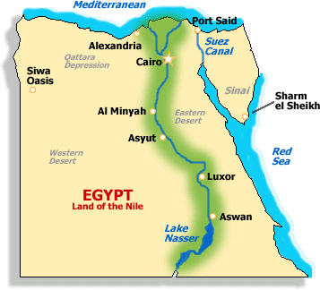Science
- What were the natural barriers that protected Ancient Egypt?

- How did the people of Ancient Egypt use the Nile in everyday life?

- Refer back to earlier lessons (Human/Environment Interaction) in order determine how the people of Ancient Egypt might have used the Nile River to create an economy? Use evidence (quote) from the article to support your idea.

Tombs Discovered in Egypt
Ancient mummies--some more than 4,700 years old--have been unearthed in Egypt
May 24, 2010
By Jonathan Rosenbloom
Archaeologists have discovered 45 ancient Egyptian tombs in Lahoun, Egypt. The site is about 70 miles south of Cairo, Egypt's capital. Most of the tombs hold a decorated painted wooden sarcophagus, or coffin. Each one contains a mummy. In one tomb, 12 coffins from around 1500 B.C. were found stacked on top of one another, so the actual number of mummies comes to 57. Egypt's Supreme Council of Antiquities announced the discovery on Sunday. The group oversees Egypt's artifacts as well as archaeologists searching for treasures in the North African nation.
The oldest tombs that were unearthed date back to around 2750 B.C. The discovery will give scientists more information about Egypt's ancient religions, the council said.
Mummy's the Word
Egypt's archaeology chief, Zahi Hawass, said many of the mummies are wrapped in linen that shows drawings of ancient Egyptian gods. The linen is also decorated with texts from the Book of the Dead. The book contains instructions and information that ancient Egyptians thought would help dead people deal with obstacles that they would come across in the afterlife.
Abdel Rahman El-Aydi is the head of the archaeological team that made the discovery. He said some of the tombs are decorated with religious texts. The ancient Egyptians believed these texts, like the Book of the Dead, would help the dead person to cross through the underworld.
El-Aydi said one of the oldest tombs is almost completely intact and hasn't been touched since it was sealed thousands of years ago. It contains urns and containers, as well as a wooden sarcophagus containing a mummy wrapped in linen.
The recent discovery of the 45 tombs isn't the first in Lahoun. Last year, some 53 stone tombs dating back to various ancient periods were found in the same area.

- Who wrote this article?

- When was it written?

- What type of scientist does the article mention that we have learned about in this unit and what type of tools might they have used in this discovery? Use evidence (quote) from the article to supports your answer.

