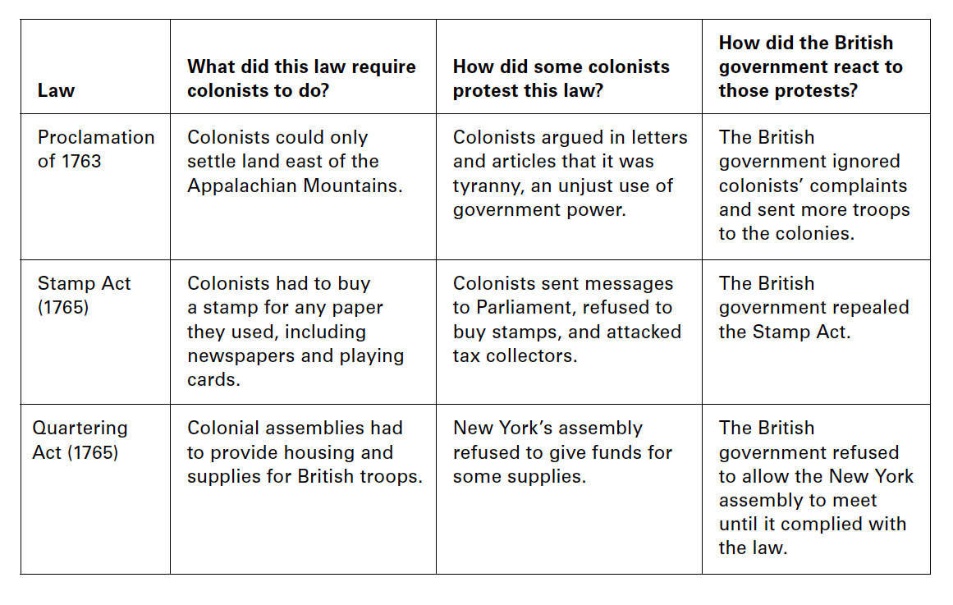

Background to remember:
- Colonial governments elected their own assemblies, passed laws, and created taxes and decided how to use them.
- In 1754, George Washington and his men opened fire on a French scouting party in the Ohio Valley. This event began the French and Indian War or Seven Years War.
- In 1759, British troops captured Canada. This was an important turning point for the Americans, who had suffered many losses to the French.
  - The British were in debt largely due to the F&I War – over 100 million Pounds.
- The territory in North America controlled by Great Britain expanded greatly. Colonists felt proud to be British and hopeful for the future.

Town Hall Meeting 1
Proclamation of 1763
For: If the colonists move past the Appalachians, Indians will attack them.

Against: The only new land available for settlement is on the other side of the Appalachian Mountains.

Stamp Act
For:

Against:

Quartering Act
For:

Against:
Town Hall Meeting 2
- The Townshend Acts placed a duty, or tax, on certain goods the colonists imported from Great Britain.
- The Acts were passed to raise money for Great Britain’s army in the colonies.
- Lord North repealed the Townshend Acts because the taxes were not raising enough money to cover the losses due to the boycott.
The Townshend Acts were fair / unfair…

The Boston Massacre was / was not justified …

Town Hall Meeting 3
- After the Boston Tea Party, King George no longer simply wanted to collect taxes from the colonists. He now wanted to take control of the colonies.
We believe the Tea Act is fair /unfair because …

- The Intolerable Acts had FOUR main parts to them:
  - They closed Boston Harbor to shipping
  - The British government (Parliament and the king) now controlled the government in Massachusetts
  - Any British soldier accused of murder would have their trial in England, not the colonies
  - More soldiers were sent to make sure the colonists followed the laws.
- The results included…
  - Merchants in other colonies closed their shops to oppose the treatment of colonists in Massachusetts.
  - Virginians called for a meeting of delegates from all the colonies to find a peaceful solution.
  - Some towns and cities began to organize militias.
  - Patrick Henry urged colonists to unite by thinking of themselves as one group of people: Americans.
  - The First Continental Congress decided to send a message to King George asking him to recognize their rights. The Congress also called for a new boycott of British goods until the Intolerable Acts were repealed.
We believe the Intolerable Acts are fair / unfair because …

Town Hall Meeting 4
The battles at Lexington and Concord were / were not justified because …

