
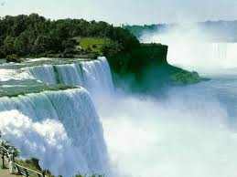
The Mid-Atlantic Region of the United States
Maryland, Delaware, Pennsylvania, New Jersey and New York


Check out the best states on the east coast! Experience cities, beaches, and the Appalachian Mountains!

Interesting facts about the Mid-Atlantic states
- Delaware was the first state to ratify the U.S. Constitution in 1787, so is known as the “first state”. Its state bug is the ladybug and the state beverage is milk.
- The state of Maryland was named to honor the Queen consort Henrietta Maria (1609-1669), the wife of Britain's King Charles I.
- Grover Cleveland was born in Caldwell, NJ. He was the United States’ 22nd and 24th President.
- Four U.S. Presidents were born in New York including Teddy Roosevelt and Franklin Delano Roosevelt!
- The Philadelphia Phillies have gone to the NLDS every year the last four years.
- Make sure to include at least one fact per state in this region…
You can visit Washington DC, our nations capital, and see many different monuments including the Lincoln Memorial and the Vietnam War Memorial. Travel up north to Philadelphia, Pennsylvania, and you can visit the Liberty Bell and Independence Hall. End your tour of the Mid-Atlantic States in New York by visiting the big city or beautiful Niagara Falls!

A picture of Niagara Falls, taken from http://www.eastcoastedventures.com/trips/niagarafalls:

What to DO and SEE in the Mid-Atlantic region!
A picture of Delta Middle School students in front of our nations capitol, Washington DC, which borders Maryland.
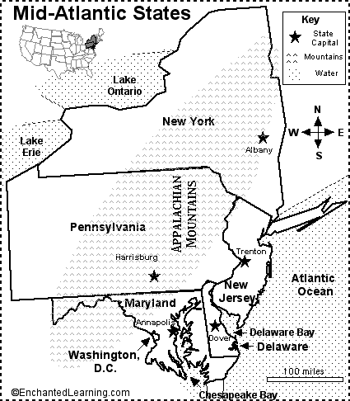
Answer the questions below in a paragraph:

What physical and human characteristics do these states have in common? What makes this area a region?

…. Give at least 3 details, 5-8 sentences

Physical characteristics

These states are located along the middle of the east coast of the Atlantic Ocean.
Delaware: the Delaware Bay, the Delaware River, and the Atlantic Ocean

Maryland: Alleghany Mts., Appalachian Mts., and Blue Ridge Mts., Potomac River, Atlantic Ocean, Chesapeake Bay

New Jersey: Delaware River, Hudson River, and Atlantic Ocean

New York: Hudson River, Mohawk River, Genesee River, Lake Ontario, Lake Erie, Lake Champlain, and the Atlantic Ocean

Pennsylvania: Allegheny River, Susquehanna River, Delaware River, Ohio River, and the Appalachian Mts.
List at least one physical characteristic per state

Human characteristics
Delaware:
- Population: 783,600
- Capital: Dover
- Industry: business, agriculture, and tourism
Maryland:
- Population: 5,296,486
- Capital: Annapolis
- Industry: farming, mining, fishing and govt.
New Jersey:
- Population: 8, 414,350
- Capital: Trenton
- Industry: farming, chemicals, and tourism
New York:
- Population: 18,976,457
- Capital: Albany
- Industry: finance, fashion, tourism, communications, and international trade
Pennsylvania:
- Population: 12,281,054
- Capital: Harrisburg
- Industry: steel, farming, mining, electronics equipment

