STUDY GUIDE & CROSSWORD PUZZLE

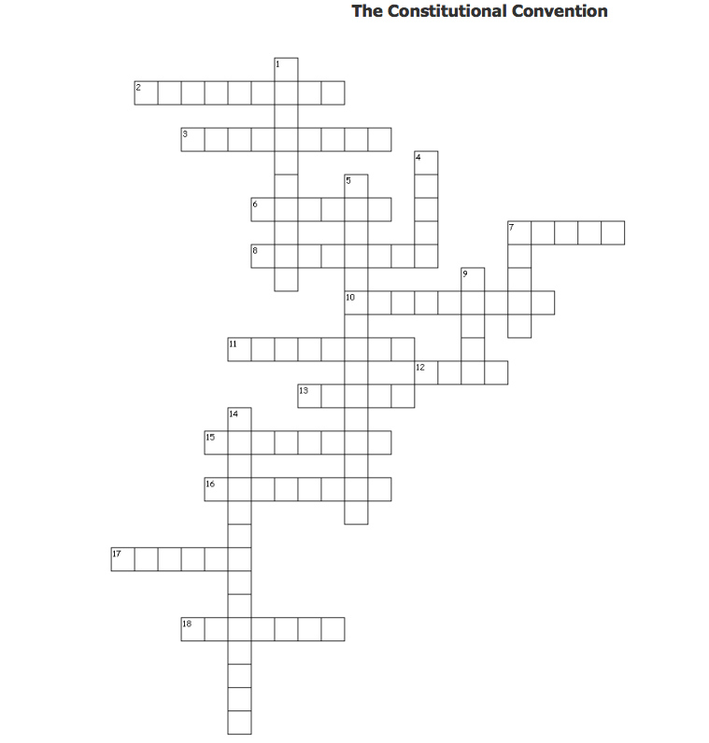

Across
2. When the population reaches 60,000, a territory can apply for ___.
3. The delegates to the Constitutional Convention gave the job of choosing a chief ___ to electors chosen by the states.
6. The greatest challenge for the delegates at the Constitutional Convention was how to balance the interests of large and small ___.
7. Shay's Rebellion happened because farmers had difficulty earning enough to pay their debts and ___.
8. According to the Three-Fifths Compromise ___ could not tax exports to other countries.
10. The Federalists ___ the new constitution.
11. A federal system of government shares power between the ___ and state governments.
12. To pass the Three-Fifths Compromise the Convention added the fugitive slave clause, which required that escaped slaves had to be returned to their owners even if captured in a ___ state.
13. The greatest concern of the opponents to the Constitution was giving up ___ power to form a stronger Union.
15. The delegates to the Constitutional Convention agreed to establish a country led by elected representatives, which is called a ___.
16. An effect of Shay's Rebellion was that Congress called for a convention to revise the ___ of Confederation.
17. The Land Ordinance of 1785 addressed the issue of how to ___the western lands acquired by the United States in the Treaty of Paris.
18. ___ is banned in the Northwest Territory.

Down
1. Slaves were counted as three-fifths of a person when determining a state’s ___.
4. Madison was known as the "Father of the __" because he was well prepared to lead the discussion at the convention.
5. The number of members in the House of ___ is affected by state population.
7. Both the Virginia and New Jersey Plans included ___ branches of government.
9. According to the Three-Fifths Compromise Congress could not interfere with the slave ___ for 20 years.
14. The Great Compromise decided ___ in Congress.

