____________________
October 19, 2015
SS, Period _________
Work hard. Be nice.
Test Corrections for Unit 1 – Use your chapter packets, old notes, and the textbook from the last unit to help you!! http://glencoe.com/ose/ Use the ACCESS/ CLASS CODE: D1671C47FA

Question #_____
Correct Answer (full answer): ____________________________________________________________
_____________________________________________________________________________________
Why is this answer correct? : ____________________________________________________________
_____________________________________________________________________________________

Question #_____
Correct Answer (full answer): ____________________________________________________________
_____________________________________________________________________________________
Why is this answer correct? : ____________________________________________________________
_____________________________________________________________________________________

Question #_____
Correct Answer (full answer): ____________________________________________________________
_____________________________________________________________________________________
Why is this answer correct? : ____________________________________________________________
_____________________________________________________________________________________

Question #_____
Correct Answer (full answer): ____________________________________________________________
_____________________________________________________________________________________
Why is this answer correct? : ____________________________________________________________

Question #_____
Correct Answer (full answer): ____________________________________________________________
_____________________________________________________________________________________
Why is this answer correct? : ____________________________________________________________
_____________________________________________________________________________________

Question #_____
Correct Answer (full answer): ____________________________________________________________
_____________________________________________________________________________________
Why is this answer correct? : ____________________________________________________________
_____________________________________________________________________________________

Question #_____
Correct Answer (full answer): ____________________________________________________________
_____________________________________________________________________________________
Why is this answer correct? : ____________________________________________________________
_____________________________________________________________________________________

Question #_____
Correct Answer (full answer): ____________________________________________________________
_____________________________________________________________________________________
Why is this answer correct? : ____________________________________________________________
_____________________________________________________________________________________

Question #_____
Correct Answer (full answer): ____________________________________________________________
_____________________________________________________________________________________
Why is this answer correct? : ____________________________________________________________
_____________________________________________________________________________________

Question #_____
Correct Answer (full answer): ____________________________________________________________
_____________________________________________________________________________________
Why is this answer correct? : ____________________________________________________________
_____________________________________________________________________________________

Question #_____
Correct Answer (full answer): ____________________________________________________________
_____________________________________________________________________________________
Why is this answer correct? : ____________________________________________________________
_____________________________________________________________________________________

Question #_____
Correct Answer (full answer): ____________________________________________________________
_____________________________________________________________________________________
Why is this answer correct? : ____________________________________________________________
_____________________________________________________________________________________

Question #_____
Correct Answer (full answer): ____________________________________________________________
_____________________________________________________________________________________
Why is this answer correct? : ____________________________________________________________
_____________________________________________________________________________________

Question #_____
Correct Answer (full answer): ____________________________________________________________
_____________________________________________________________________________________
Why is this answer correct? : ____________________________________________________________
_____________________________________________________________________________________

Question #_____
Correct Answer (full answer): ____________________________________________________________
_____________________________________________________________________________________
Why is this answer correct? : ____________________________________________________________
_____________________________________________________________________________________

Test Corrections for Short Constructed Responses (SCR)
Question #_____ Original Score: _____
According to the CHECKLIST what was missing from your Short Constructed Response? Circle the criteria you were missing.
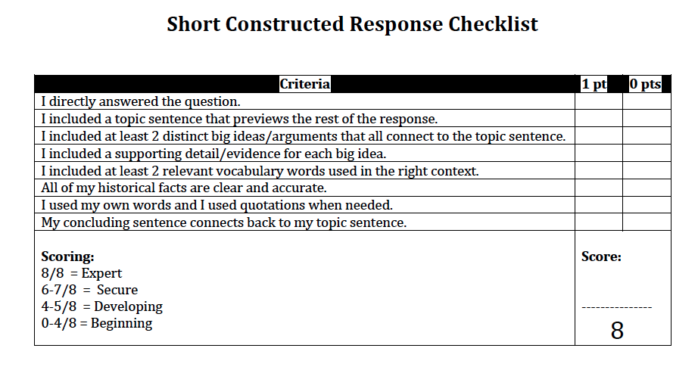

Write a SECURE or EXPERT Short Constructed Response below. When done put a check √ next to all the criteria you have met on the CHECKLIST. Add up the points you have earned.
_______________________________________________________________________________________________________________________________________________________________________________________________________________________________________________________________
_______________________________________________________________________________________________________________________________________________________________________________________________________________________________________________________________
__________________________________________________________________________________________________________________________________________________________________________

