UNIT 1, ANCIENT ROME: Misconceptions and Important Concepts to Review

The Republic was ancient Rome’s government for over 500 years until the rise of the “Empire”.
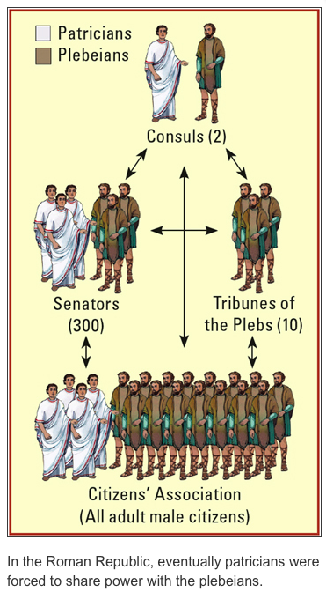
The Plebeians Gain Political Equality: The patricians agreed to let the plebeians elect Tribunes of the Plebs and the Council of Plebs. Around 451 B.C.E., the Twelve Tables were published. By 287 B.C.E., assemblies of all citizens could pass laws. Plebeians governed with patricians. The plebeians had won their fight for equality.

The Republic is Relevant to Today: Other countries adopted the following characteristics from the Roman Republic: a written constitution, elected assemblies, citizenship, civic duty, checks and balances, and a spirit of republicanism or democracy.

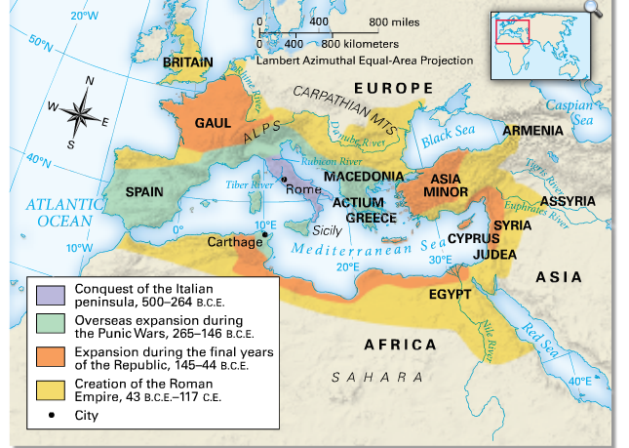

- Daily Life in Ancient Rome: Nearly one million people lived in the city of Rome. The Forum was its center. The empire had many large cities, but most people lived in the country.
- Law and Order: Romans believed in the rule of law. Laws were strict, but crime was common. Any Roman could accuse someone else of a crime. A jury decided the case.
- Religion: Religion was part of daily life. Romans made offerings to the gods. Festivals and holy days were held throughout the year. Each home had an altar for household gods and spirits. The Romans also honored their emperors as gods.
- Family Life: Each family was ruled by the paterfamilias or the oldest living male. At nine days old, a baby was given a bulla, which he or she wore throughout childhood. Between 14 and 18, a boy became a man. Girls became adults when they were married, between 12 and 18.
- Food, Drink, and Housing Only the rich had kitchens. The poor cooked on small grills or bought “fast food.” The main foods were bread, beans, spices, vegetables, cheeses, meats, and garum. Drinks included water and hot water with herbs and honey. The rich lived in large houses, built around a central atrium (hall, courtyard or pool). The poor crowded into apartment buildings.
- Education and Recreation Many poor children in Rome learned trades, instead of going to school. Wealthier boys and girls were tutored by their fathers or by slaves until they were about 6. Then boys went to school. Roman boys learned Latin, Greek, math, science, literature, music, and public speaking. Upper-class boys stayed in school until age 12 or 13. The rich enjoyed plays and musical performances. Both rich and poor often relaxed at Rome’s public baths. Besides celebrating many festivals, rich and poor alike enjoyed viewing gladiator contests and chariot races.
- Country Life Ninety percent of the empire’s people lived in the country. The wealthy often owned villas. Farms provided much of the food for the cities. Slaves did much of the farm work. Many country people were not slaves, but their lives were hard. They lived in huts and worked their own small farms or on the great estates.

An Overview of Ancient Rome

313 CE, Constantine gives Christians the freedom to practice religion openly; by 326 CE Rome’s capital moves to Byzantium, renamed Constantinople after Constantine
49 BCE, Julius Caesar is named “Dictator” marking the decline of the Republic.
494-287 BCE, Plebeians rebel due to unfair laws
509 BCE, Roman Republic formed
753 BCE, Rome Founded
476 CE, Fall of the Western Roman Empire; the Eastern Empire continues as the Byzantine Empire
31 BCE – 14 CE, The rule of Emperor Augustus; he begins the Pax Romana “time of peace” while also expanding
264 - 146 BCE, Punic Wars – Rome defeats Carthage making Rome the strongest empire in the Mediterranean
509 - 264 BCE, Romans take over the entire Italian peninsula; Roman’s fight the Latins and Etruscans; Rome wins
0
200 CE
400 CE
200 BCE
400 BCE
600 BCE
800 BCE

